**SSL Stream Converter**

SSL Stream Converter is a web application. You can covert multiple non-SSL(HTTP) streams to SSL(HTTPS) streams using SSL Stream Converter.

1. First, you need to download the .zip file.

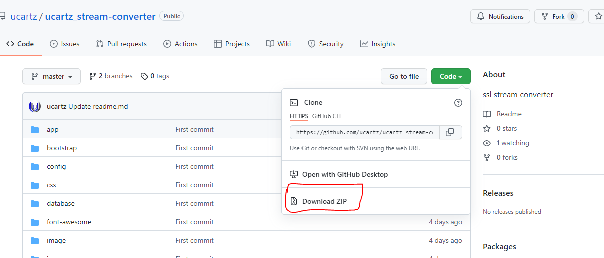

2. Upload file "ucartz_stream-converter-master.zip" to your host inside the desired location using cPanel File Manager.

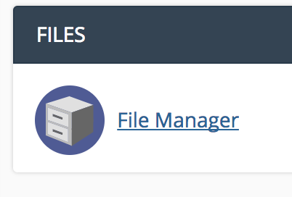

3. After upload is completed, Right click on the package and select Extract. That will extract the zipped file contents.

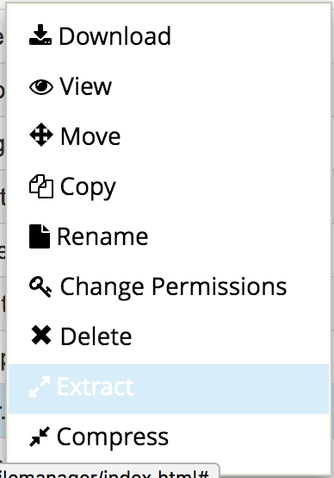

4. Within the extracted files, you can see a file, named vendor.zip, and you need to extract this file, either.

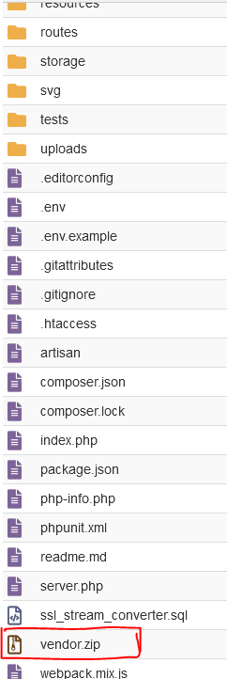

## 5. Database and database user creation

* Log into your cPanel.
* Click the MySQL Database Wizard under the Databases heading.

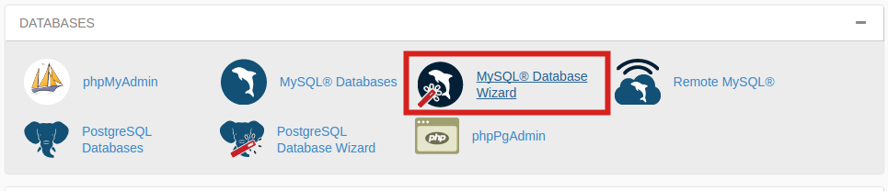

6. Next to New Database enter a name for your database and click Next Step.

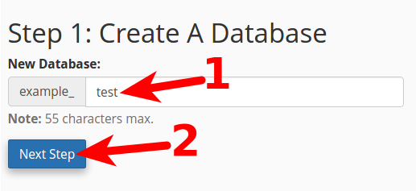

7. Next to Username enter a username.Enter a password next to Password, enter it again for Password (Again) and then click Create User.

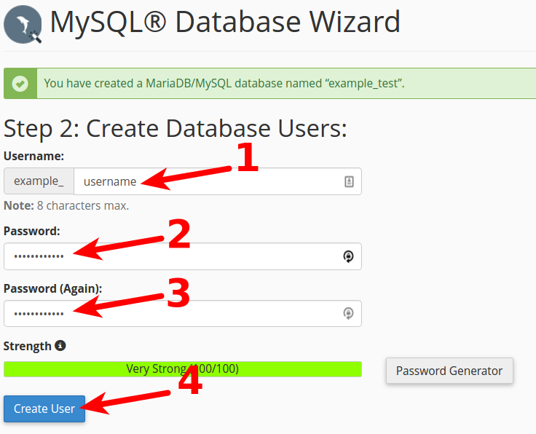

8. On the next page, you'll assign privileges for the user to the database. Check the box next to All Privileges and then click Next Step.

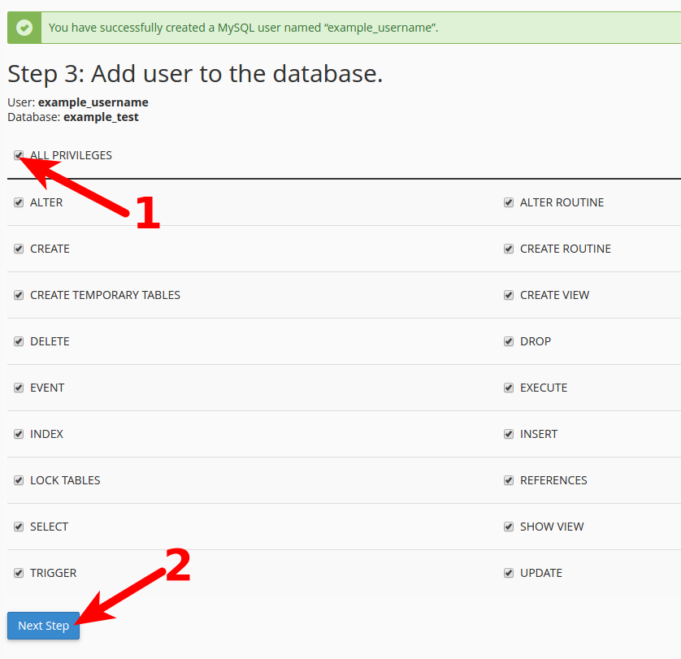

9. Get/Download the **ssl_stream_converter.sql** file from the root directory.

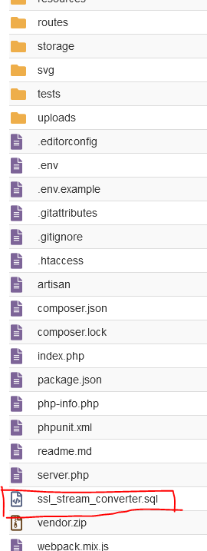

10. Import the same in to the database. (Open the database and select import then choose the ‘**ssl_stream_converter.sql** ’ and go )

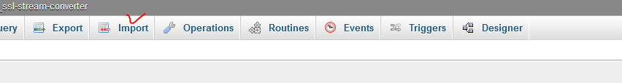

11. Once completed, enter the database details (DB_DATABASE, DB_USERNAME, DB_PASSWORD) into the **.env**file.  
  
**Note:** If you don't see the **.env** file, go to settings and tick the option "Show hidden files" (applicable only if you are using the cPanel control panel).

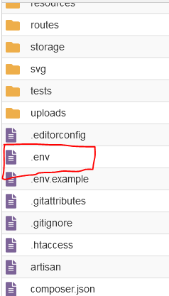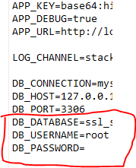

Now you are ready to use the Ucartz Stream SSL Converter.

* 12. Open your favourite browser and then open the URL—for instance, [**https://yourdomain/**](https://yourdomain/)**or**[**https://yourdomain/yourfolder**](https://yourdomain/yourfolder)**.**